

DAA Lab Assignment


Submitted By:
Name: Bhavy Lavania Roll No.: 2301201140
Course: BCA (Sp. In AI & Data Science) Sem- 5th^{rd} Semester

DAA Lab Assignment – 2

Problem 1: Scheduling TV Commercials to Maximize Impact
- Algorithmic Strategy: Greedy (Job Sequencing)
- Application Domain: Media & Advertisement
- Problem Description: You are given a list of commercials, each with a deadline and revenue. Schedule non-overlapping commercials to maximize total revenue

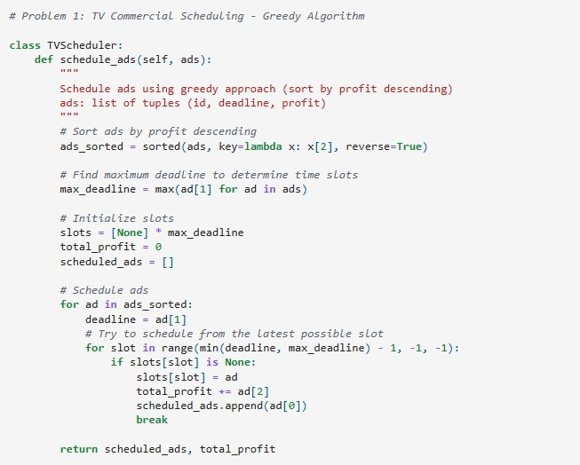

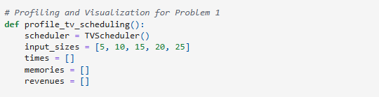
Output:

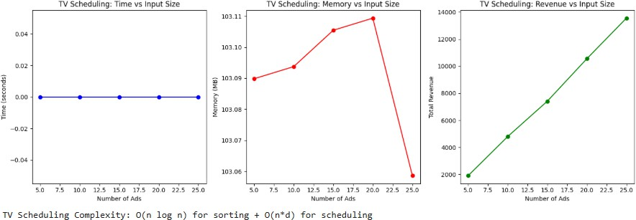

Problem 2: Maximizing Profit with Limited Budget
- Algorithmic Strategy: Dynamic Programming (0/1 Knapsack)
- Application Domain: Investment, Budget Planning
- Problem Description: Choose a subset of projects or items that give maximum profit within a limited budget
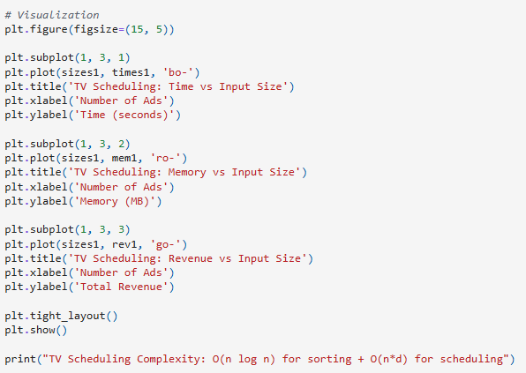

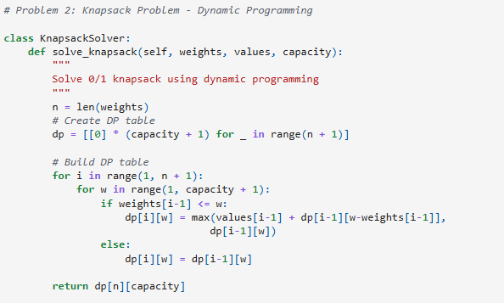

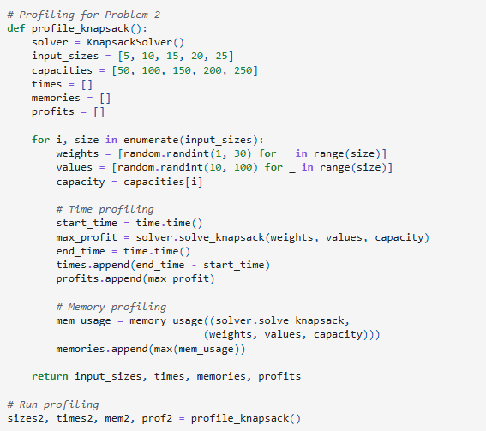

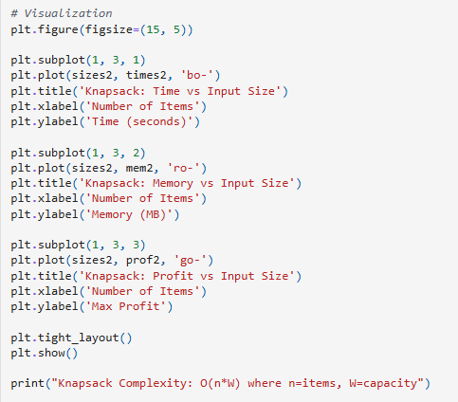

Output:
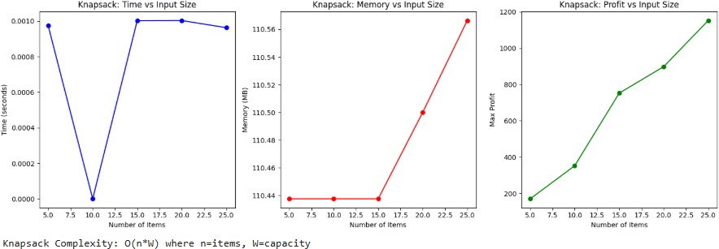

Problem 3: Solving Sudoku Puzzle
- Algorithmic Strategy: Backtracking
- Application Domain: Gaming, Puzzle Solvers
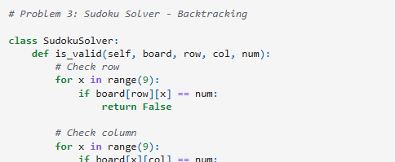
- Problem Description: Fill a 9x9 Sudoku grid such that each row, column, and 3x3 box contains all digits from 1 to 9.

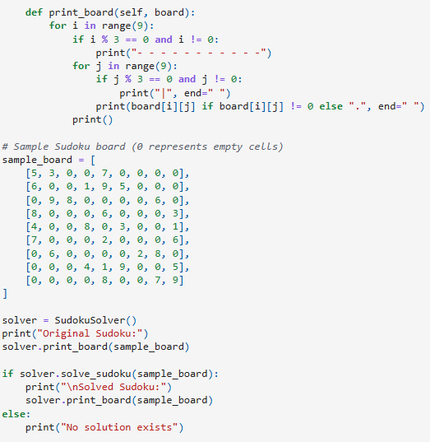
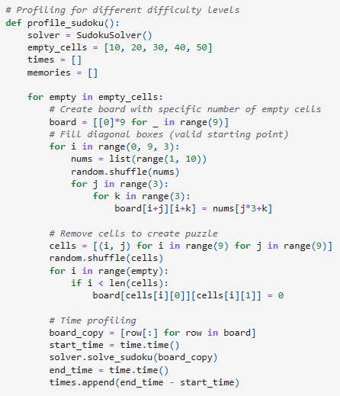

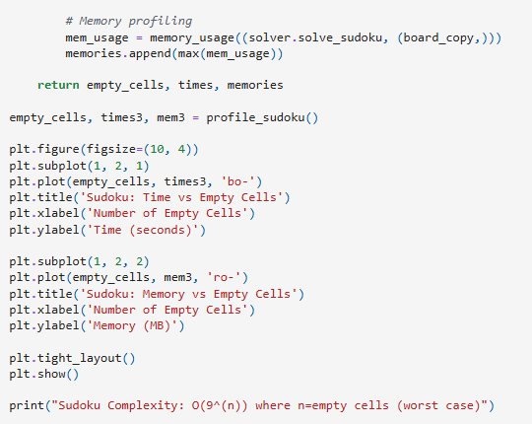

Output:
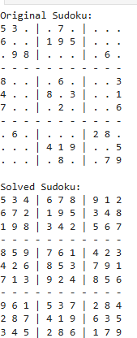

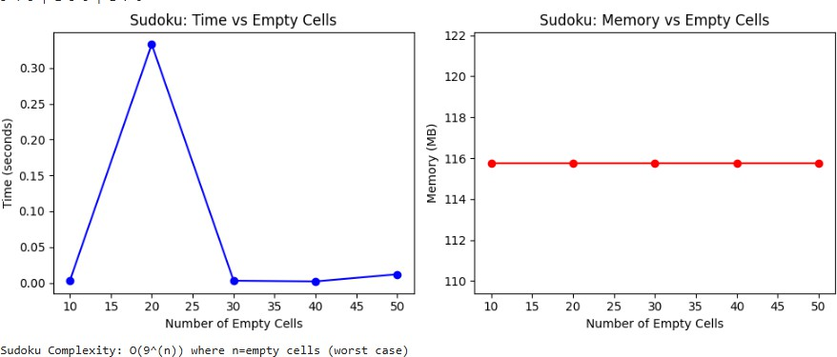

Problem 4: Password Cracking (Naive)
- Algorithmic Strategy: Brute-Force
- Application Domain: Cybersecurity
- Problem Description: Attempt to crack a given password using all possible character combinations from a known charset.

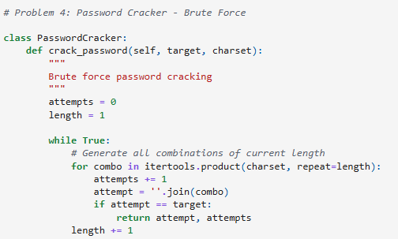

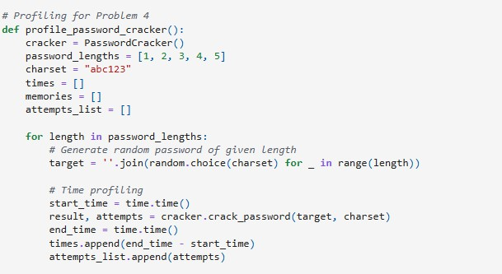
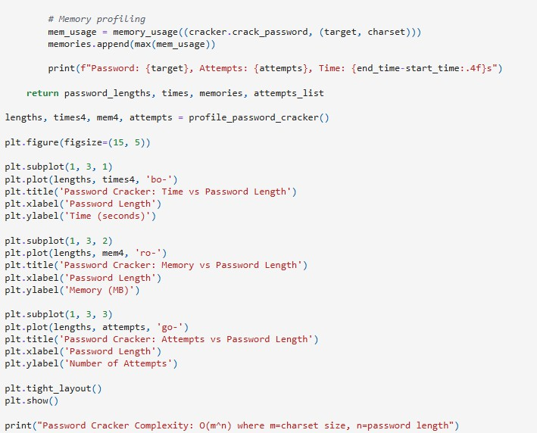

Output:
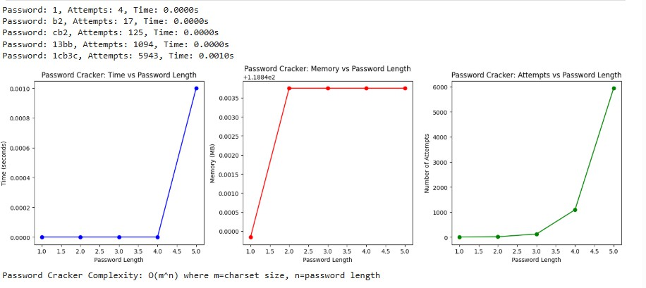
Task 4: Final Summary and Documentation Summary table comparing all four problems:
Problem | Strategy | Time  Complexity | Domain | Notes
T.V.  Commercial Scheduling | Greedy | O(n log n + n*d) | Media & Advertisement | Schedule ads to maximize revenue before  deadline
Knapsack | Dynamic Programming | O(n*W) | Budget Planning | Maximize value without exceeding  budget
Sudoku Solver | BackTracking | O(9^n) | Gaming | Fill grid under constraint  satisfaction
Password Cracking | Brute-Force | O(m^n) | Cybersecurity | Try all combinations to guess  password

Insights and Observations:
- TV SCHEDULING (Greedy):
  - Observed: Linear time growth with input size

  - Theoretical vs Actual: Matches expected O(n log n) behavior
  - Best for: Problems where local optimal choices lead to global optimum

KNAPSACK (Dynamic Programming):
  - Observed: Polynomial time growth, but memory intensive
  - Trade-off: Time efficiency vs space complexity
  - Best for: Optimization problems with overlapping subproblems

SUDOKU (Backtracking):
  - Observed: Exponential time growth with empty cells
  - Stack usage: High due to recursion depth
  - Best for: Constraint satisfaction problems

PASSWORD CRACKER (Brute-Force):
  - Observed: Exponential explosion with password length
  - Practical limitation: Becomes infeasible beyond 5-6 characters
  - Best for: Small search spaces or when no better algorithm exists

Github:
https://github.com/BluntPhoenix04/DAA-Lab_Assignment/Lab_Assignment-2

